SESSION 8
Gearhaven — The Clockwork City
Beat 1 — The Road to Gearhaven & First Steps in the City
An illustrated chapter — read the gold boxes aloud; purple boxes are for the DM.

Previously, on The Guardians of Elaria…
Last time, our heroes did something amazing. In the haunted town of Wraithpine, a monster called the False Hydra sang a secret song — a song that made everyone forget the people it ate. Families were vanishing, and nobody even remembered they were gone. But you remembered. You followed the song down into the dark beneath the old theater, and you cut that monster’s heads off one by one until its song finally went silent. The whole town woke as if from a bad dream — and remembered the people they’d lost, and the three heroes who saved them.
Deep in the lair, you found a chest wrapped in silver vines and starlight. Inside were three gifts, each marked with a seven-pointed star — the sign of the sleeping goddess Elaria. A staff of constellations for Ursa. A swift silk sash for Stabby. A pocket-sized cannon-core for Lilly. And your little plant-friend Floraburst breathed in a wisp of ghost-light and changed — into the pale, glowing, chiming spirit who floats beside you now. Ghostbloom.
You have questions. Big ones. What are the cracks splitting the world? What is the Sphere that holds Pikachu’s spark, and how do you bring him back? There’s one place famous enough to hold the answers: a great city of inventors called Gearhaven, where they say the artificers can build anything. So you pointed yourselves east, and you walked.

The Journey
The road to Gearhaven took three days.
The first day was forest, soft and green. The second, the land turned to rolling farmland, and you started to see signs of the city long before the city itself — fence-posts that ticked like clocks, a scarecrow with brass joints, a farmer’s cart that rolled on its own little gears. The third day, the air began to taste different. Like hot metal and coal-smoke and something sharp, like the smell right before a thunderstorm.
You traveled the way you always do. Stabby ranged far ahead and far behind, never still for a second, scouting every noise and turning every walk into a race — he climbed three separate trees just to see if he could. Ursa walked quietly, watching the night skies each evening, reading the stars like a map and pointing the way east when the road forked. And Lilly filled the silence with ideas, tinkering as she walked, taking apart one of those little brass farm-gadgets to see how it worked and putting it back together better. Ghostbloom drifted along above you all, chiming whenever the wind changed.
By the third evening, your feet ache, your packs feel heavy, and you’re hungry for a hot meal and a real bed. And then — the trees suddenly end.

The Reveal
You’re standing on a high ridge, and the whole valley below is full of city.
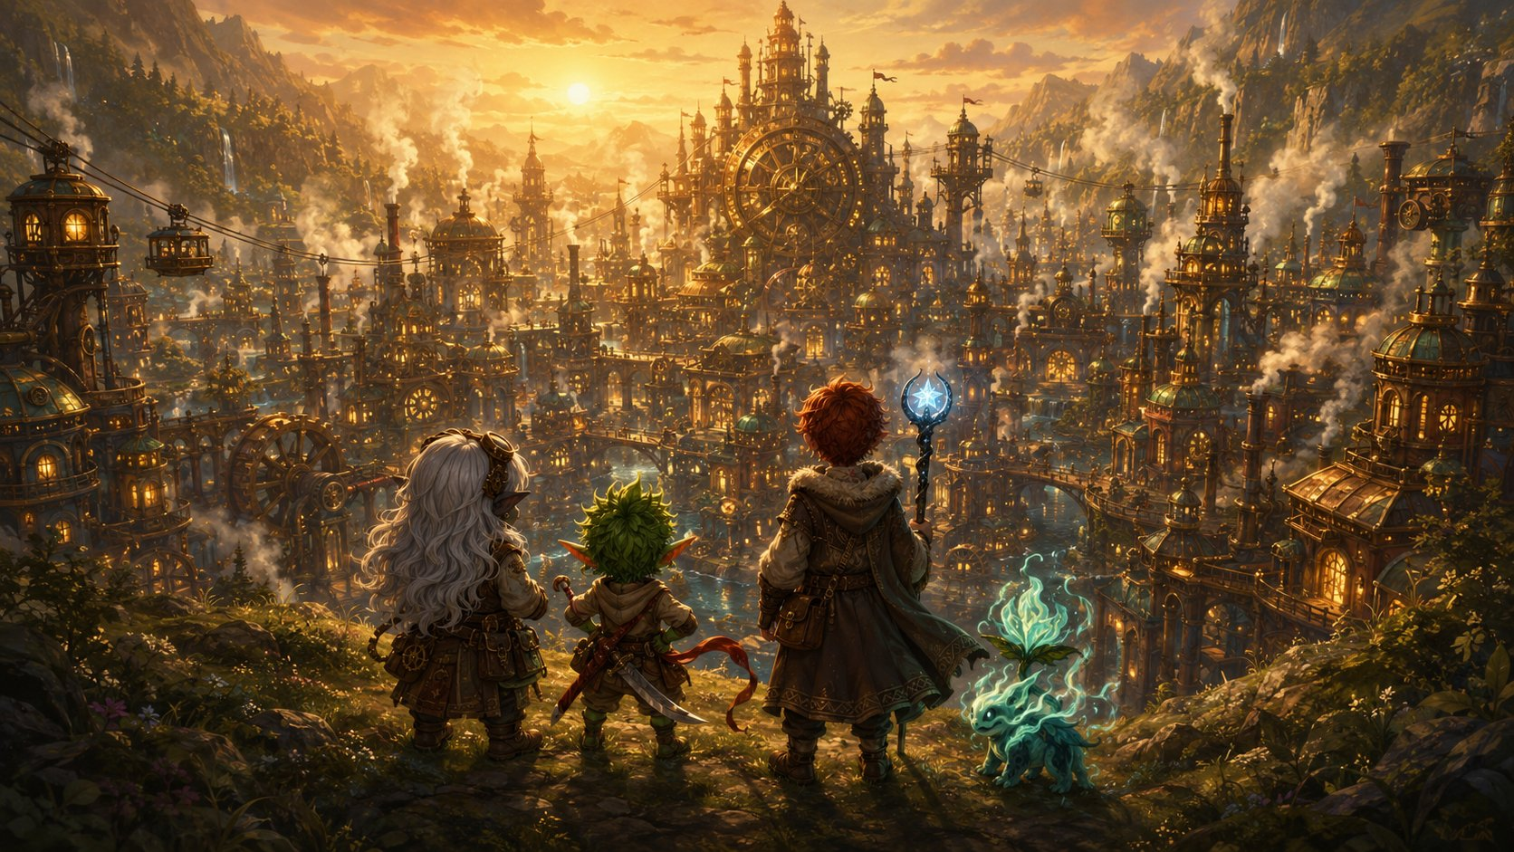
The Guardians crest the ridge and see Gearhaven for the first time.
Towers of brass and copper stretch toward the sky, breathing ribbons of white steam. Rooftops shine like a field of gold coins in the last of the sunset. Little carriages made of gears and cable zip between the buildings on humming wires, high above the streets. And right in the heart of it all, something enormous turns — slow, steady, patient — so big you feel its heartbeat in your chest before you ever hear it. Boom. Boom. Boom.
Ghostbloom’s petals dim, then flare bright. And in Lilly’s pack, the Essence Sphere does something it has never done before: it gives one warm, gentle pulse. Like a heartbeat answering a heartbeat. Like it knows this place. Like it’s coming home.
Welcome to Gearhaven.

Through the Gate
A wide road winds down the ridge to the city’s eastern gate, where two enormous brass doors stand open, carved all over with gears and stars. Above them, a great clock face shows not just the hour but tiny moving pictures — the moon, the tides, the turning seasons, all ticking along together.
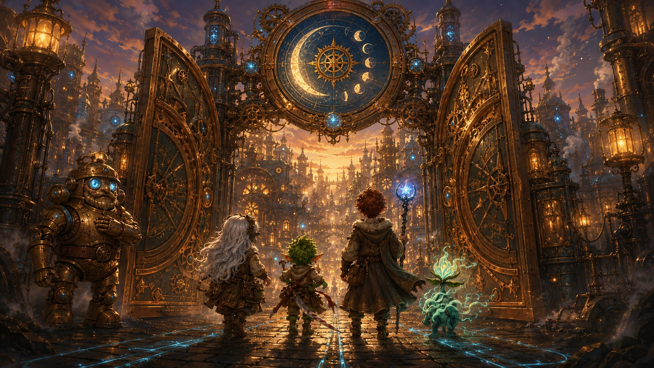
The eastern gate of Gearhaven — and its clockwork gnome gatekeeper.
A guard steps forward to meet you — but the guard isn’t quite a person. It’s polished copper and brass, shaped like a stout little gnome, with a soft blue glow behind its eyes and a voice like a wind-up music box. It taps its chest-plate twice.
“Welcome, travelers. Steady gears to you.”
It looks the three of you up and down — a gnome, a goblin, a boy with a glowing staff, and a little ghost-flower bobbing in the air — and tilts its head with a soft, curious whirr.
“Hmm. Not your usual merchant caravan. Gate-logs, if you please: what names do I write, and what brings such an unusual little company to Gearhaven?”
▶ First talk-opening. Let each kid answer in their own words — or read them their suggested line. This is where the group says who they are and why they’ve come.
Lilly: “Lilly Glimmergear, artificer. I’m carrying something special — and I need the Guild’s help to understand it.”
Stabby: “Name’s Stabby. We’re here for answers. And snacks. Mostly answers. Definitely snacks.”
Ursa: “Ursa Catchum. We’ve followed the cracks in the world — and the stars — a long way. We’re looking for the Artificer’s Guild.”
The Mechagnome’s quill scratches busily across a brass tablet, then pauses at the word “cracks.” Its blue eyes flicker — just for a second, like a candle in a draft — before brightening again.
“The Guild, yes. Everyone’s bound for the Guild this week. Up Cogtooth Hill — ask for Guildmaster Vane. Mind the machines, though. They’ve been… restless. Steady gears to you, travelers. You may need them.”
Then the city swallows you up in noise and color. Steam hisses up warm from grates in the cobblestones. Glowing blue lines run through the streets like the whole place is lit from underneath. Trams hum by overhead on humming cables. And everywhere, under everything, that giant heartbeat. Boom. Boom. Boom.

The Street of Small Wonders
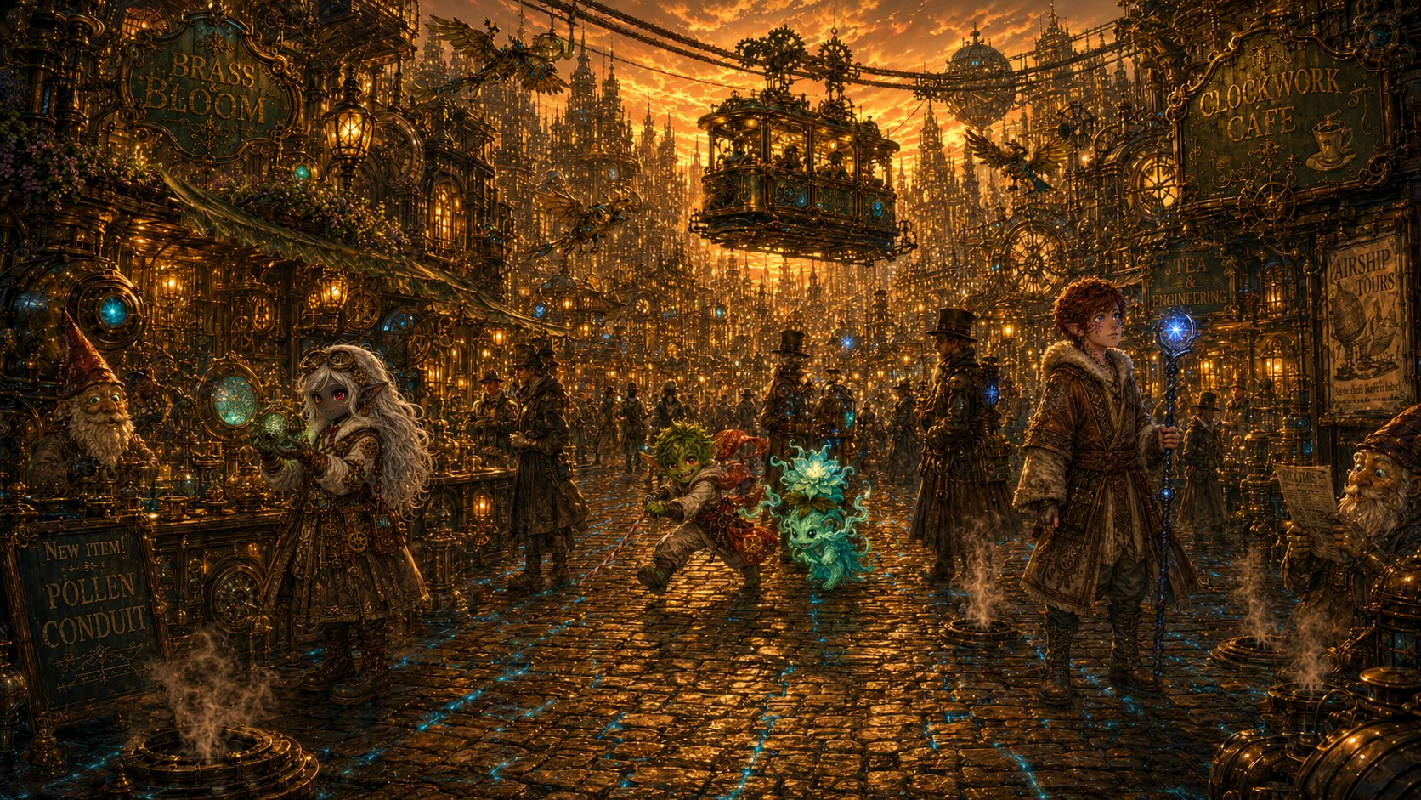
Wandering the Street of Small Wonders at golden dusk.
The main road is called the Street of Small Wonders, and it earns the name. You barely know where to look first.
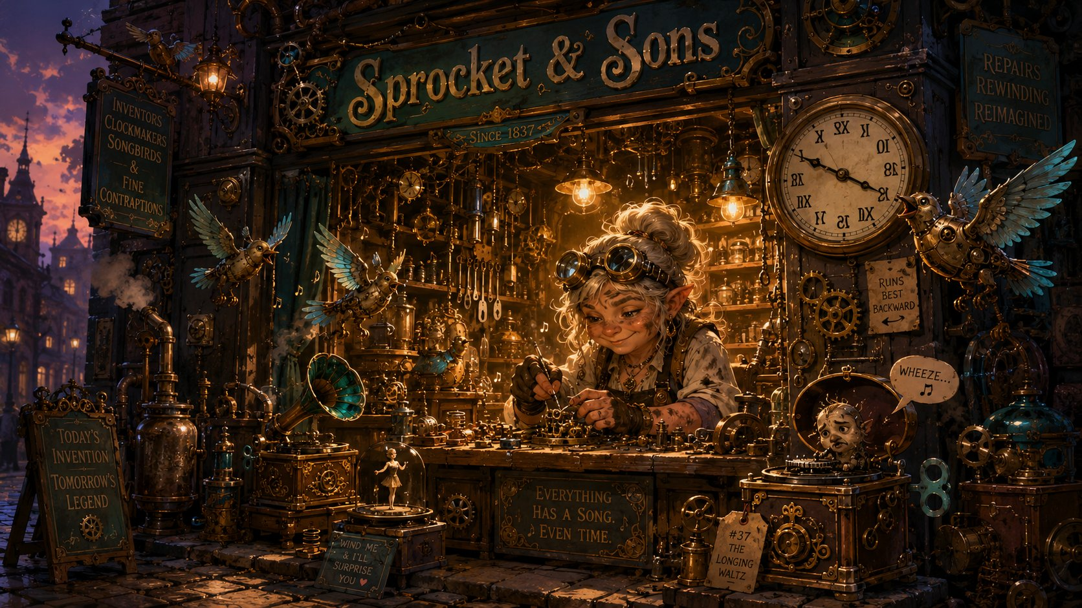
Sprocket & Sons — Mara at her cluttered workbench.
A cluttered little shop called Sprocket & Sons spills gadgets onto the street — self-winding music boxes, mechanical songbirds, a clock that runs backward. The owner, a soot-smudged gnome woman named Mara Sprocket, spots Lilly’s tools and lights right up.
“Oho — a maker! I can always tell. Those are good tools, little one — but what’s a young artificer doing all the way out here? What’re you building?”
Lilly: “I’m not building it — I’m trying to understand it. It’s called an Essence Sphere. The Guild’s supposed to be able to help.”
Mara’s eyebrows shoot up at those words.
“An Essence Sphere! Now there’s a word I haven’t heard outside of old Glimmerspire books. You’ll want Vane, then — Guildmaster, up on Cogtooth Hill. Brilliant fellow. Working on something big, they say — something that pokes holes in the sky, if you believe the rumors.”
She winks, then thumps a sputtering music box. It plays three notes and dies with a sad little wheeze. “Mind how you go, though. Half the gadgets in this city have gone wonky this week. Even mine.”
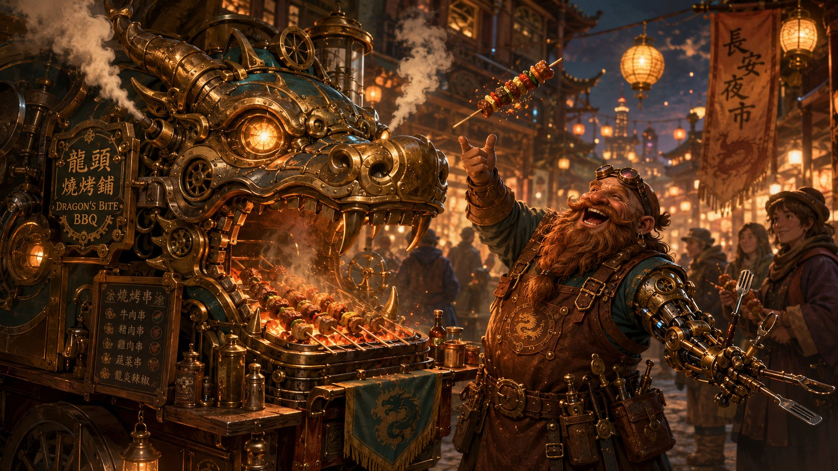
Burl and the Dragon’s Bite BBQ cart.
A little farther on, a food cart shaped like a dragon’s head puffs real steam from its nostrils, frying skewers of spiced meat. The cook — a one-armed dwarf with a brass replacement arm full of cooking tools — catches Stabby eyeing the skewers and flips him one, fast as a dart.
“Quick eyes! Quick hands too, I’ll bet. Here — on the house. So what’s a sharp little thing like you doing in my city? Trouble, I hope?”
Stabby: “Always trouble. But today? We’re hunting answers. My friends have got big mysteries, and I’ve got a big sword. It works out.”
The dwarf roars with laughter.
“Hah! I like you. Name’s Burl. You three want answers, you want the Guild — and you want that scatterbrained Vane up the hill. Tell him Burl says he still owes me for three skewers and a singed eyebrow!”
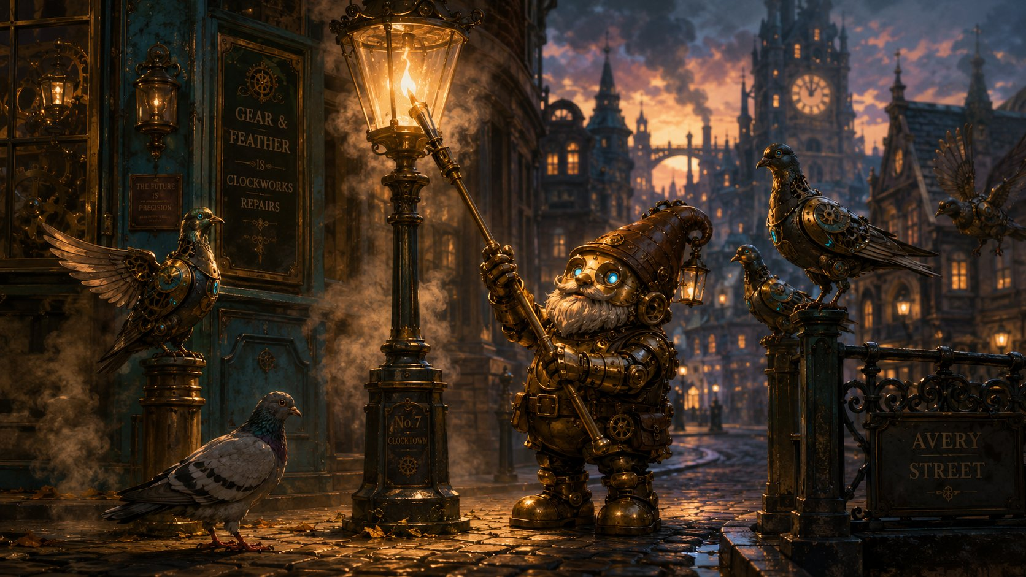
Tock the lamplighter — and a pigeon that won’t leave Ursa’s staff.
Then a flock of clockwork pigeons clatters down from a rooftop — and so does one real one, a scruffy gray bird that lands right on Ursa’s staff, tilts its head, and refuses to leave. Its owner, an old Mechagnome lamplighter named Tock, shuffles over, peering with softly glowing eyes.
“Well now. She doesn’t take to just anyone. Animals know a kind heart when they see one.”
His gaze drifts to the seven-pointed star on Ursa’s staff, and his voice goes quiet.
“…And that’s Elaria’s mark. Haven’t seen it in a long, long while. Tell me, star-child — what is it you’re really looking for, all the way out here?”
Ursa: “My father. He disappeared chasing the cracks between worlds… and I think the answers are here, somewhere. In the stars, or in the Guild’s records.”
Tock is quiet a moment, the little gray pigeon ruffling on the staff.
“Old questions, then. The deepest kind. You’ve come to the right city — the Guild keeps records older than this whole street. Ask for the archives. Ask for Vane. And mind the machines on your way. They’ve not been themselves this week.”
He shuffles off to light the next lamp, glancing back once.
Three different people, three different shops, and every single one says the same things: the machines have been acting strange all week… and whatever you’re after, you’ll find it at the Artificer’s Guild, with a brilliant, scatterbrained inventor named Guildmaster Vane.
But it’s getting dark. As you wonder where to sleep, a tram glides to a stop beside you, and its conductor leans out — a nervous, fidgety Mechagnome with fluttering brass hands.
“Oh — visitors! You look lost, dearies. The Guild’s shut till morning, I’m afraid — locked up tight, strange week we’re having.”
Her blue eyes flicker, just once.
“I’m Pinion, by the way. If it’s a warm bed you’re wanting, you tell Henna at the Gilded Gear that Pinion sent you. Best stew in the district!”
Pinion returns tomorrow — she’s the conductor wrestling the malfunctioning servitors in Beat 2. Her flickering eyes (like the gatekeeper’s) are the Mechagnomes quietly sensing the planar trouble before anyone understands it.

The Gilded Gear
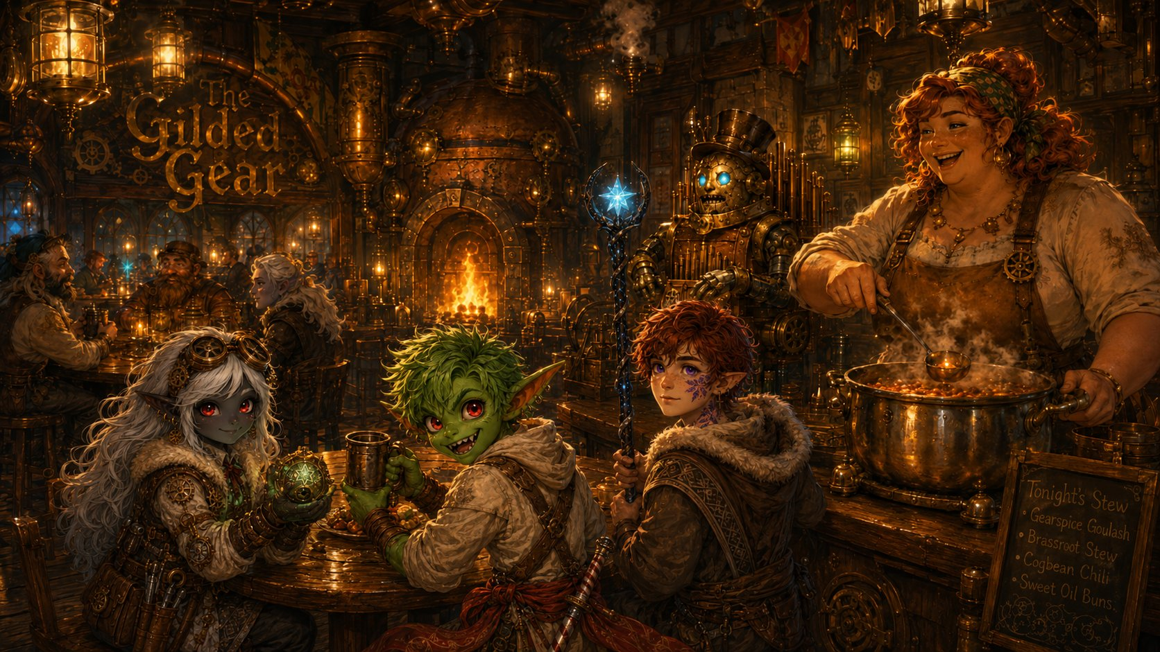
The Gilded Gear — Henna Brasspot ladles the first bowl, on the house.
The Gilded Gear is the warmest, goldenest, happiest-sounding place you’ve seen in three days of hard road. A tall, crooked building with brass pipes running up the outside that puff little rings of steam, and a sign shaped like a spinning cog that never stops turning. Inside, a fire crackles in a hearth shaped like an open furnace. A Mechagnome in the corner plays a pipe-organ built into its own chest. The whole place smells of roast meat, fresh bread, and warm cider.
Behind the bar is a tall, broad woman with flour on her apron, copper-red hair tied up in a kerchief, and a laugh you can hear from the door — Henna Brasspot, who owns the place.
“Travelers! And little ones too — come in, come in, you look half-starved and twice-tired! Pinion sent you? Course she did. First night in Gearhaven, the first bowl’s on me — house rule.”
She sets down three steaming bowls and leans on the bar.
“So. What brings three young ones and a… is that a flower? …all this way? Nobody comes to Gearhaven without a reason.”
▶ Anyone can answer. Suggested lines below. Henna is your recurring ‘home base’ friend — she’ll be here every time the party returns to Gearhaven.
Lilly: “We’re here to see the Guild. I’ve got something they might be able to fix… or finish.”
Ursa: “We’re following a trail — my father’s, and the cracks in the world. It led us here.”
Stabby: “And the stew. The trail definitely led to the stew.”
Henna laughs warm and loud. “A boy after my own heart! Eat up, then.” She softens as she listens, wiping the bar.
“The Guild, eh? Then it’s Vane you’ll want. Oh, he’s a genius — the real kind, the sort who forgets to eat for three days and then builds something that changes the world. Bit of a mess, mind. But if anyone can help with mysteries, it’s him and his lot up the hill.”
She lowers her voice.
“Though between us? The machines have been acting up something fierce this week. My own bread-mixer tried to take my finger off yesterday. Whole city’s a touch on edge.”
Then she straightens, smiling. “But that’s tomorrow’s worry. Tonight you eat, you rest. I’ve three soft beds upstairs with your names on ’em.”
And so, for the first time in three days, you sleep without rocks under your bedrolls — full, warm, and safe. Outside the window, the city’s giant heart beats on. Boom. Boom. Boom.
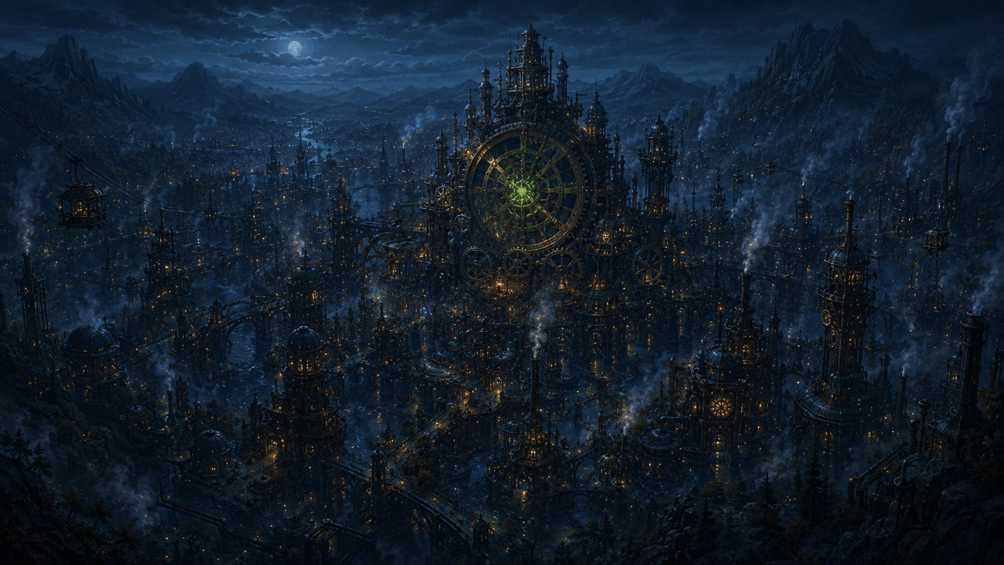
Far below, the city’s great heart skips a single beat… and something green flickers wrong.
But just as you drift off… the rhythm skips. Just once. A single missed beat in a heart that has not missed a beat in a hundred years. In Lilly’s pack, the Sphere gives the faintest, worried little pulse. And then… sleep.

End of Beat 1. Next: morning at the Cogtooth Market — and the machines stop being ‘restless’ and start being dangerous. (Fight 1.)

